“Edible Me” Testing Report

Sam Yan
Student ID: 0930756
Department of Computer Science
@Wenzhou-Kean University

“Edible Me” is a decision making project which recommend food and drinks to registered users according to their body and health status specified in the proposal. Those factors of different body conditions and health status include users’ diseases that they are suffering from, users’ current BMI, users’ preferences, users’ flavor preferences and the consideration of food safety issues between different kinds of food.
Thus, to test this implemented project, the structure of the program is studied according to the design specification. The program structure includes three layers, the first is the database design which was implemented using MySQL 5.7. The second layer is the database linker which is used to link between the database and the subroutines. This layer is used to process the the interactions between programs and user data, including reaching data from database and storing data back into database. Furthermore, in order to consider the possible extension of the user requirements in the future, the data linking layer could serve as server side programs if later on the Server-Client model needs to be implemented. The third layer is the project framework which directly interacts with application users, dealing with their input and outputs and provides certain functions to satisfy software specifications.
The testing strategies are formed according to those 3 levels of the whole project. The database design and implementation is tested according to the rules of 4NF database design requirements, the program linker phase is each tested by using sample testing classes while the project framework is tested by running this application in the virtual machine environment to estimate whether the instructions are clear for users and whether the graphical user interfaces follow the rules of user friendly and hinting properly.

- Project Structure

The database is designed and implemented according to the requirements of 4NF. The 4NF database relationship specifies that there should be no multiple value dependencies between non-trivial and non-functional relationships. It is based on the prerequisites of BCNF, 3NF, 2NF and 1NF. Among those normal forms, 1NF specifies the requirement that their should be primary key(s) in the database which is designed. 2NF specifies that each column of the database should form one-to-one relationship to its corresponding primary key(s). 3NF specifies that their should not exists inductive relationships between columns and BCNF is the improving normal form of 3NF which specifies that each of the primary key(s) should decide(s) certain one-to-one factors. The database design following the rule of 4NF and the implementation using MySQL 5.7 as specified in the software requirement together works as the first layer of the application.
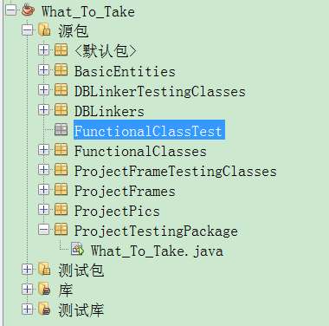
Fig: Package management of “Edible Me”
In the implementation of this application, the package management strategy is used to divide classes or contents of different subroutines into different layers or function specifications. For example, package BasicEntities is implemented according to the project class diagram design specified in design specification. Those entities are implemented using Visual Paradigm for UML version 10.0, by directly generating and importing the corresponding project codes into the project path after the finishing of project designing phase.
DBLinkers forms “links” from program subroutines to databases, thus, the separation from programs to data is satisfied because user programs are not allowed to manipulate data in the database directly in this case, instead, those subroutines are supposed to first achieve data in the database and then processes data based on their interactions with users.
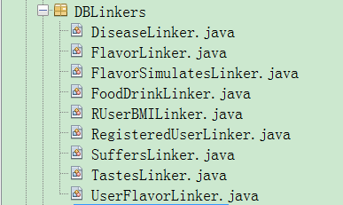
Fig: Subroutines linking to database
For example, DiseaseLinkers in the package DBLinkers works as the link between the information of various kinds of diseases in database and it provides subroutine functions as shown below:
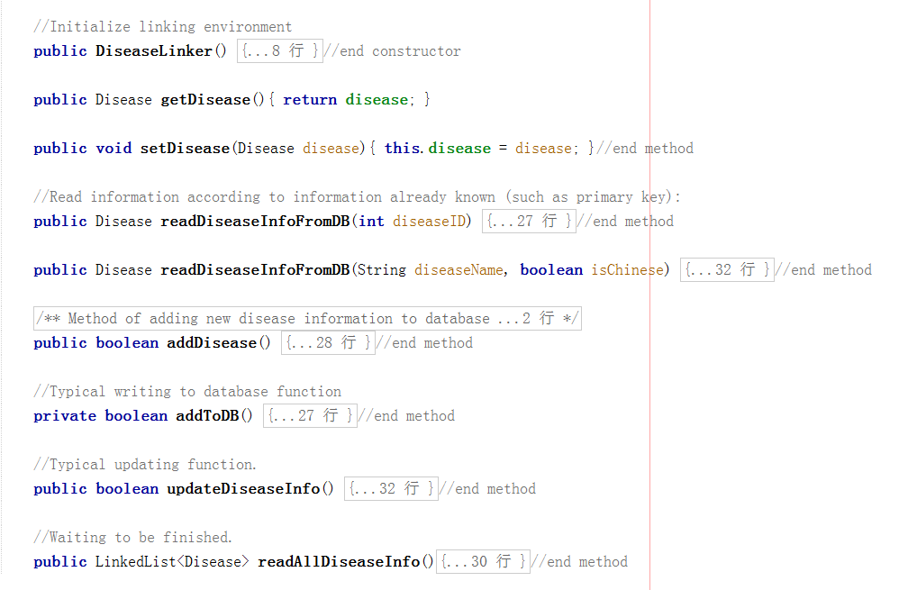
Fig: Subroutines of DiseaseLinker class

Thus, for other programs or routines that needs to reach information about different diseases users might suffers from, they could possibly call the function of this program. For example, to inquiry about the full information about certain type of disease, either the name of the disease (can be both in English or Chinese, taking into the consideration of possibly extending a Chinese version of this application later on) or the ID of the disease (possibly achieved from other applications) shall serve as a possible input for this linking class. The output in the case is the full information of this type of disease to the caller program. Also, caller programs might possible require to record information about new diseases into database, thus they could use this link class by first set the full information of certain disease that they could provide, and then after setting the information about the disease by calling either addToDB() or updateDiseaseInfo() function to achieve their goals.
Other subroutines of this package works similarly as DiseaseLinker class. For example, FlavorLinker reads and writes information about different flavors, FlavorSimulatesLinker keeps information about which types of flavors tend to simulate what kind of diseases and FoodDrinkLinker keeps information about various food and drinks.

The third level of this project is the user interface level, which also includes some functional classes which combines different functions in order to satisfy different purposes specified in software specification. This level of subroutines are included in both ProjectFrames and FunctionalClasses.
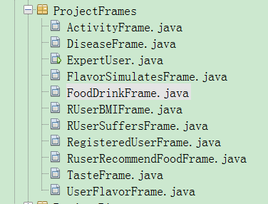
Fig: Structure of ProjectFrames

ProjectFrames are Graphical user interfaces which directly interacts with application users. They are developed using GUI Designing system of Netbeans 8.2.
Take the example of how RegisteredUserFrame works. This frame is used for registered users to record their food and drink taken during the day, to record their flavor preferences, body conditions and health conditions. Also, through this frame, users can get their recommended dishes. The frame implements most of the requirements specified in the software requirement specification for registered users. As for expert users and vendor users, their frame structure is similar registered users’ frame.
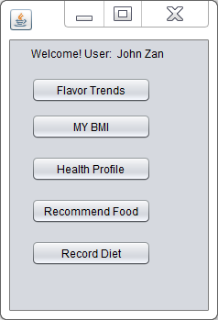
Fig: Registered user interface

Based on users’ needs, the user can then click on different buttons designed for different functional requirements. By clicking flavor trends, for example, the user can update information about his or her preferred flavors.

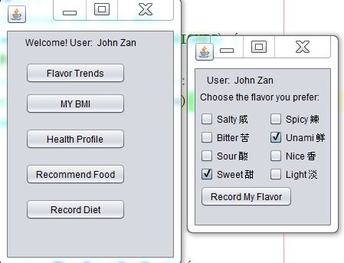

Fig: Menu of Users’ flavors

Similarly, other functional requirements shall be satisfied by clicking other different buttons on user menu.

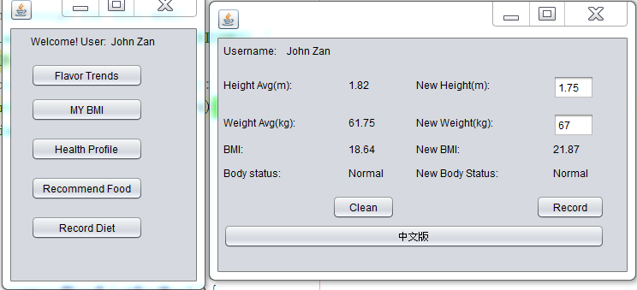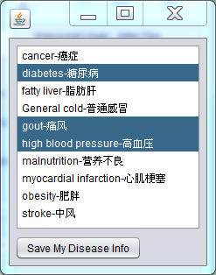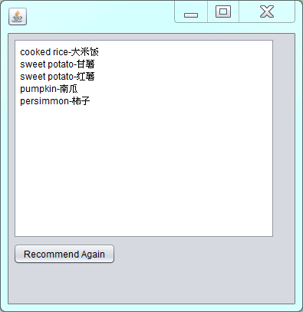
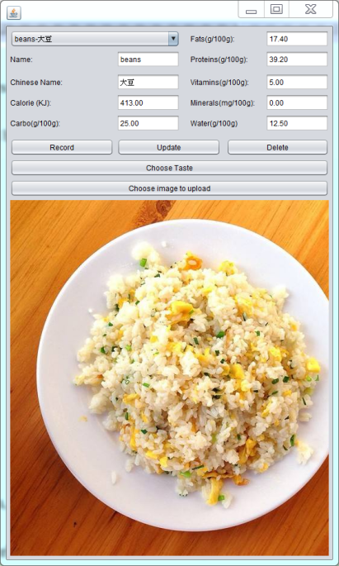
Fig: Corresponding results by clicking on different user frames for registered users

- Testing Strategies

- Database Linking layer test
For each of the database linking subroutine, a program which simulates using this linking subroutine while running the program is written. For example, for the data linking class DiseaseLinker, which fetches disease information or write reported new diseases should be tested its functions of reading a certain disease information from database, writing a certain disease into database and update information about a certain disease in the database. This is the “white-box” testing of a DBLinker class because it “goes into” the subroutine to test every section of its implementation details. If after executing all the procedures the result returns as expected, the “black-box” testing in this case in then no need because in this case the inputs and corresponding expected outputs are guaranteed.

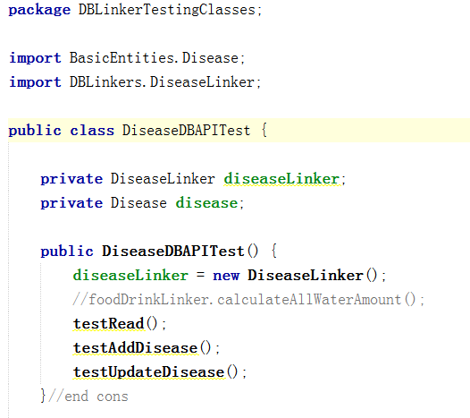
Fig: General view of testing codes for DiseaseLinker

Then, to test reading disease information from database, some simulated cases of requiring getting a type of disease is written, as shown below:

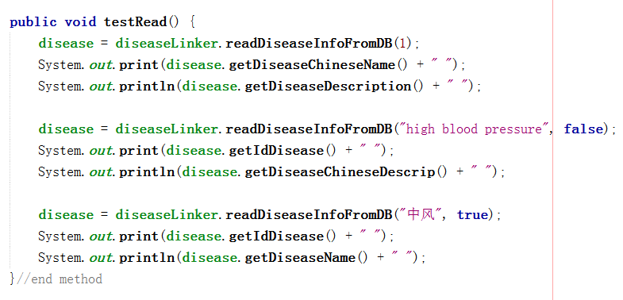
Fig: Black testing of reading certain diseases from database

Similarly, to test writing disease and updating disease information from database, simulated cases are designed and tested, the corresponding subroutines are as shown below:

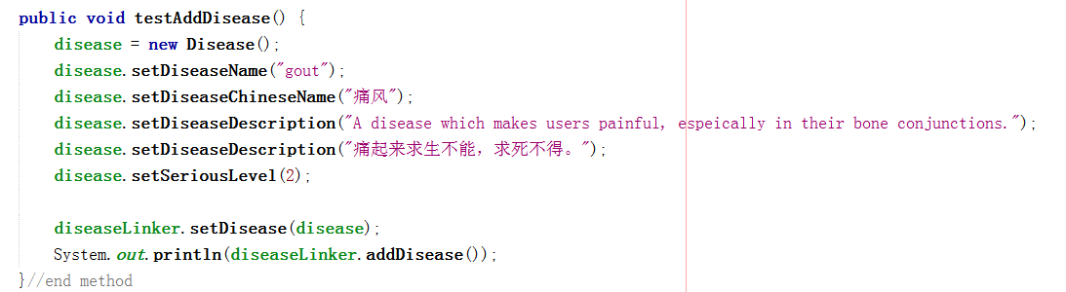
Fig: Black testing of adding a new disease information from database

Fig: Black testing of updating the information of a certain disease

As for the testing cases of other database linking subroutines, the strategies are similar to this subroutine.

- Project Framework test
The project frameworks are used to link to database linking subroutines to read and write data from the user side, while they directly interact with program users. Thus, it is important for those interfaces to be able to interact well with databases and application users. During the phase of testing user frameworks, both the project and the database application are under observation. However, due to the finishing of linker program tests, the linking programs are treated as “black boxes” which are able to get correct input and give out expected outputs. Thus if problems occur, it is more likely that the framework sides are biased.
Another issue needs to be considered is exceptional inputs from users. Take the example for reading the calorie number of certain kinds of food. The expected value is actually of the format floating points, but in real usages it might be possible for users to input non-value texts, such as “h” for users may accidentally press wrong buttons. The user frameworks shall be robust enough to deal with unexpected user inputs.
Thirdly, the user-friendly cases of the interfaces shall be taken into consideration. Issues such as whether hints and instructions for users are clear or not, whether the frame achieve all the functional goals shall all be taken into consideration.

- Security policy test

This project uses SHA-1 to encrypt users’ passwords using API (Application programmable interface) commons-codec-1.10.jar. Thus, the correctness of this API also needs to be tested, making sure that it is able to produce expected results. Because this application already distinguishes different users by their different username and password, it is considered that their information is confidential if their password is not being exploited for their information for other aspects are decided one-to-one to this user only, plus without their agreement, those information is not even achievable by expert users who will be strictly being checked during their registration. However, attackers are always not guaranteed to be inaccessible, all the security policies for this application can only lower down the possibilities that users are attacked.

- Testing Results

- Database design test
During the design and implementation on platform MySQL5.7, all the requirements of 5 different normalization forms are checked one by one. The checking results suggests did not find out any pitfalls which fails to fulfill any level of normalization specified above.

- Demonstration of database linking tests

By applying the strategies stated in database linker test, all the linker classes are tested. Below shows the testing of RUserLinker class. This class links between registered user and the login frame for users. The testing case simulates user trying to log in (when username and password needs to be compared), user registering and user modifying their information, testing case subroutine is shown below:

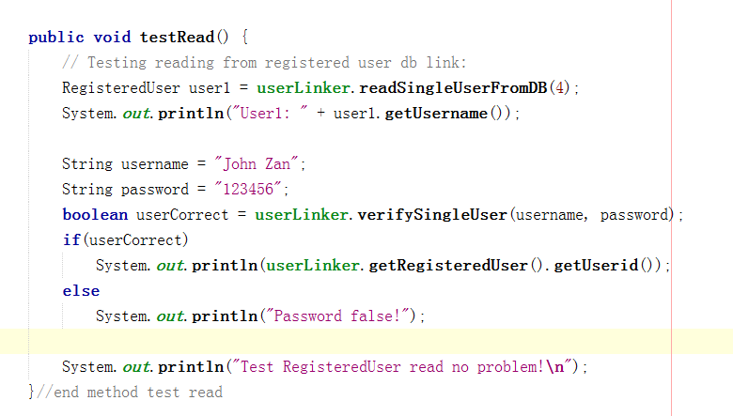
Fig: Subroutine of simulating user log in

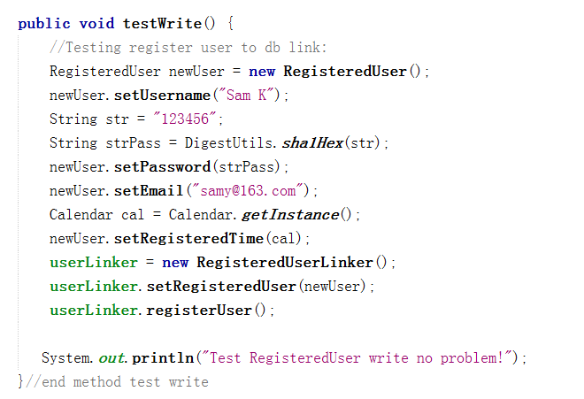
Fig: Subroutine of simulating user registering

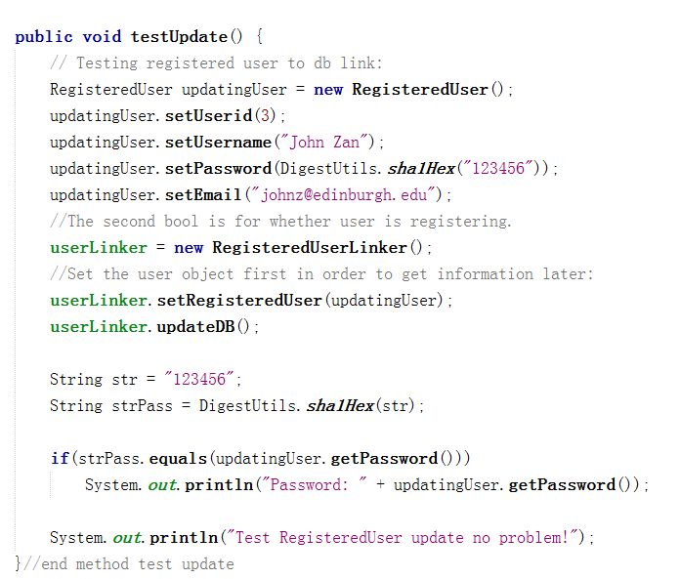
Fig: Subroutine of simulating user updating information

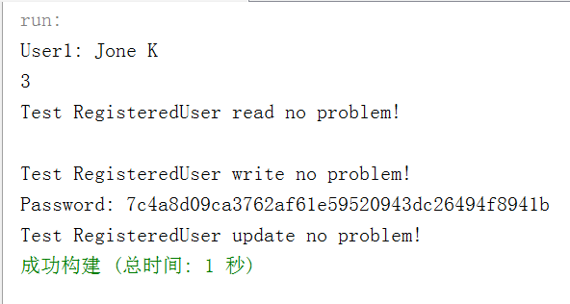
Fig: Result of first trial, new user is registered and reading / uploading not affected

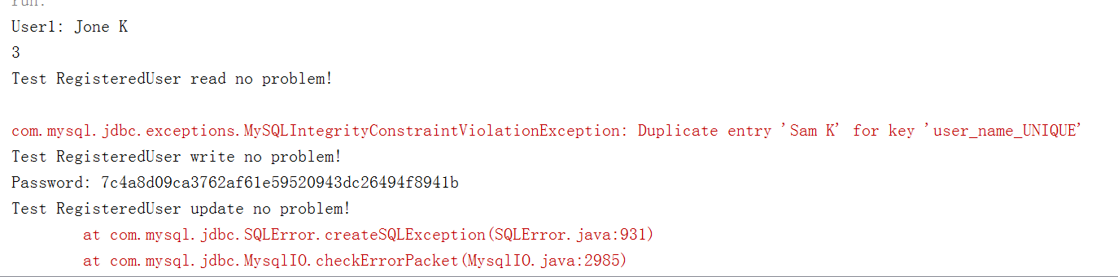
Fig: Result of the second trial, registering new user fails, while reading and updating user information not affected

Note that in the second trial, writing the new user “Sam K” into database fails, because users are supposed to be unique. This testing shows that the database system can respond correctly when meeting with the case registering two users, preventing duplicated registration and possible flooding through keeping registering zombie accounts.
Similarly, all the other database linking interfaces are tested using this approach. The results of this level of testing suggests that the linking programs all work as expected.

- Demonstration of project framework tests and evaluations

As specified before, for the testing of framework, each function of the frame is clicked to see the action of the programs.

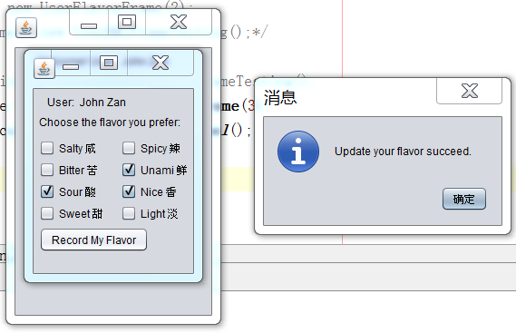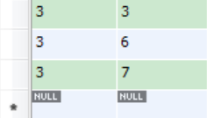
Fig: Testing results of user specifying their flavor tendencies

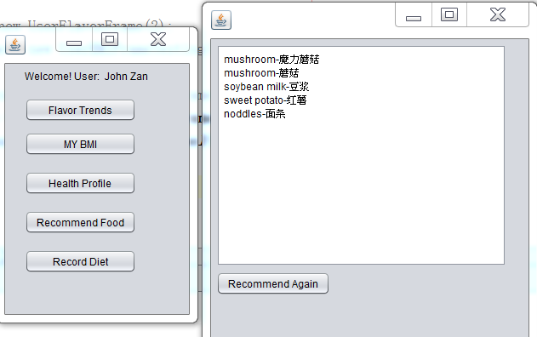
Fig: Testing results of user trying to get his/her recommended dishes

Similarly, other testings related to different registered users and expert users are tried. The results turns out to be that except getting recommended food, all other functions works as expected. However, the program might stuck sometimes when running button “Recommend Again”. Further checking suggests that the reason is due to a “dead loop” requiring to get 20 dishes as a cache, however, the actual size of all dishes is only 16. The problem shall be solved by entering more information about food and drink, for the designed sample of food / drink list is more than 20, thus automatically solving this “dead loop”.
Another issue is that those user interfaces are not friendly enough. The font is too small, together with the problem that the recommended diets are not vivid even though tool tips are designed for those buttons and columns. Plus, when users are trying to input exceptional data, the program only hints user writing to database fails, which may not be specific enough.

- Demonstration of security policy tests
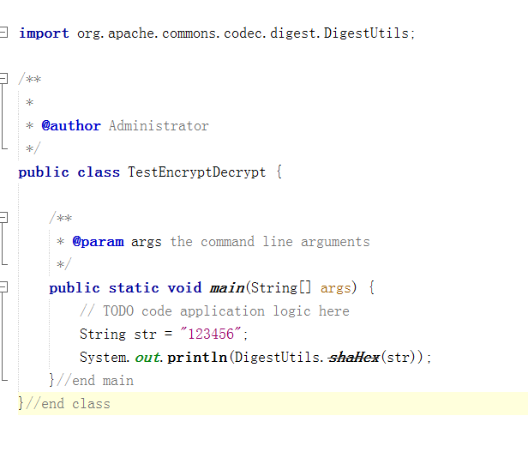
Fig: Sample testing for encryption API

In order to prove that the encryption API generates expected encrypting message, example above is used, and the result is shown below:

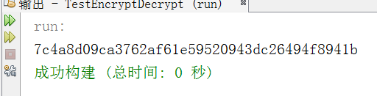
Fig: Result of encrypting message “123456” to encrypted message

This result is exactly the same by applying SQL language “INSERT INTO what_to_eat.registered_user VALUES (XX, SHA1(‘123456’)”, proving the encryption API shall work as is expected.
Fig: Result of registering user using SHA1 and whose password is 123456

Conclusion

In the testing phase of this project, all the three levels of this application, namely database designing and implementation layer, database linker layer and project framework layer are all fully tested. The results suggests that the database layer and 90% of the database linker layer programs are working as expected. Though 80% of the project frameworks are working as expected and 83.3% user functions are supported, the pitfalls of less elegantly designed graphical user interfaces needs to be further improved.

References

- Liqi, Ou, Big Talk Software Testing, in 2014, Publishing House of Electronics Industry
- Mike O’ Docherty, Object-Oriented Analysis & Design: Understanding System Development with UML 2.0, in 2005, John Wiley & Sons, Ltd
- Wang S., Sa SX, Concepts of Database system, fifth edition, in February 2016, Higher Education Press
- W. Stallings and L.Brown, Computer Security–Principles and Practice, 2nd Ed., in 2015 Prentice Hall
- Y. Daniel Liang, Introduction to Java Programming Comprehensive Version, ninth edition, in 2013, Pearson

